Exhibition of Planning Proposal 130 Killeaton Street, St Ives (PP-2022-1137)
The planning proposal seeks redevelop the site for a 5-storey residential flat building with a yield of approximately 40 dwellings.

Site description
The site is located at 130 Killeaton Street, St.Ives (Lot 1 DP 748682). It is currently occupied by a 2-storey dwelling previously used by the adjoining church and school. The site exists within an established residential area characterised by residential flat buildings to the east and west of the site, and within 1km of the St. Ives shops.
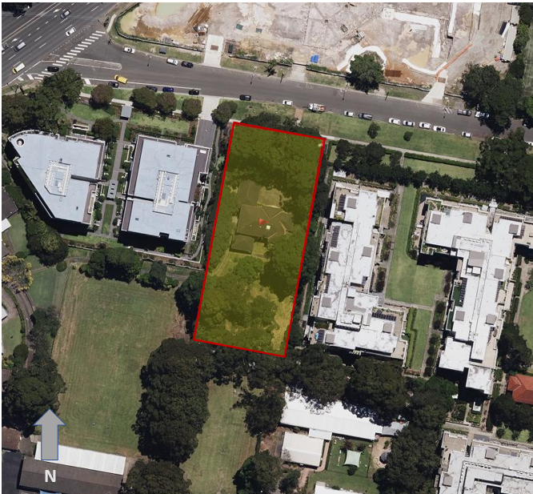

Figure 1 - Subject site (outlined in red) (Source: Planning Proposal, May 2022)

What the planning proposal will do
The planning proposal seeks to amend the Ku-Ring-Gai Local Environmental Plan (LEP) 2015 to facilitate the redevelopment of the site for a 5-storey residential flat building with approximately 40 dwellings.
In summary, it seeks to:
- rezone the site from SP2 Infrastructure (Educational Establishment) to R4 High Density Residential;
- introduce a maximum building height of 17.5m; and
- introduce a maximum floor space ratio (FSR) of 1.3:1.

What is a planning proposal?
- A planning proposal (or “PP”) explains the intended effect of a proposed LEP or proposed amendments to a LEP. It describes the intended outcomes and proposed LEP provisions, identifies and addresses the potential impacts that the changes may have and provides justification for making the LEP.
- A planning proposal is a key part of the LEP making process because it describes how a new or amended LEP will ‘give effect’ to strategic and site-specific planning outcomes. It is the first step in making the statutory link between strategic plans and planning controls which apply to development.
- Note: Any physical development of the land occurs under separate planning processes.

What is an LEP?
- An LEP provides a statutory framework for the way land can be developed and used.
- An LEP contains land use zones which establish where residential, commercial, recreation and other uses can occur. It has development controls for buildings and land, including controls for maximum building heights, floor space, subdivision and lot size.
- LEPs also include provisions which address local matters, hazards and constraints, such as flooding, protection of biodiversity, heritage conservation, or land that is being reserved by the government to build more public infrastructure in the future.
- An LEP is made under the Environmental Planning and Assessment Act 1979.

What are the Council’s, the Sydney North Planning Panel and the Department’s role in the process?

The Council’s role for this planning proposal
This planning proposal originally was submitted to Ku-ring-Gai Council on 3 June 2022. On 16 May 2023, Council resolved not to support the planning proposal. The proponent subsequently lodged a rezoning review request for the proposal, which resulted in the Sydney North Planning Panel supporting the strategic merit of the planning proposal and appointed itself as the PPA on 25 August 2023. Council is now considered a key stakeholder and will be consulted as part of the public exhibition.

Sydney North Planning Panel’s role for this proposal
- The Sydney North Planning Panel acts as the independent body in rezoning reviews within the Ku-ring-Gai Local Government Area. Given Council did not support the progression of the planning proposal, the Panel was requested by the proponent to review the rezoning request.
- The Panel determined that the proposal demonstrated strategic and site-specific merit and should proceed to Gateway determination, subject to amendments, which were made by the proponent prior to gateway assessment. The Panel was appointed as the Planning Proposal Authority and is therefore responsible for preparing the package of planning proposal documents for public exhibition and running the public consultation. The Panel will consider public submissions on the planning proposal prior to making a decision about whether the planning proposal should proceed to finalisation.

The Department’s role for this planning proposal
The Department assesses and guides planning proposals through the LEP making process. This includes active management of the planning proposal through the LEP making process, issue resolution, and finalising the LEP (if the Minister is the local plan-making authority).
- On 14 November 2023 the planning proposal was submitted to the Department for Gateway determination. An assessment of the proposal was undertaken, and a Gateway determination was issued on 22 December 2023 stating the proposal should proceed subject to the conditions, including the public exhibition of the proposal.
- A final assessment of the planning proposal will be undertaken by the Department after the public exhibition. At this stage further amendments may be made to respond to matters raised by community members or public authorities. The Department is the local plan-making authority and will determine if the LEP amendment will be made.

Additional information about the planning proposal
More information about the proposal and details about how you can get involved can be found on the NSW Planning Portal. Go to https://www.planningportal.nsw.gov.au/ppr/under-exhibition/130-killeaton-street-st-ives.

How to make submissions
Submissions on the planning proposal should be made to the Department through the NSW Planning Portal. Go to https://www.planningportal.nsw.gov.au/ppr/under-exhibition/130-killeaton-street-st-ives
Your submission must be lodged by 5pm on Friday 15 March 2024 and must include:
• if the submission relates to the planning proposal
• a statement on whether you support or object to the proposal; and
• the reasons why you support or object to the proposal.
Persons lodging submissions must declare reportable political donations (including donations of $1000 or more) made in the previous two years.

Your personal information is protected under the Privacy and Personal Information Act 1998.
We may publish any personal information you have included in your submissions on a proposal. Do not include any personal information in your submission that you do not want published. If you do not want your name and address to be made public, please ensure you tick the relevant box and clearly state this on the front page of your submission. Making a submission is entirely voluntary and you are under no obligation to provide us with any of your personal information, except as otherwise required by law.

Who should I direct my Planning Proposal inquiries to?

For questions relating to the planning proposal, please contact Alex Galea on (02) 8289 6793.

What is a Planning Proposal Authority (PPA)?
In the planning proposal process, the PPA is responsible for preparing the package of planning proposal documents and submitting them to the Department for a Gateway determination.
A Gateway determination is an approval required before the proposal can proceed to public exhibition. This approval is usually subject to conditions.
The PPA is responsible for satisfying the conditions of the Gateway determination, public exhibition of the planning proposal, and finalisation.
An alternate PPA may be appointed under certain circumstances, where directed by the Minister. As the planning proposal is the result of a rezoning review, the Sydney North Strategic Planning Panel is the Planning Proposal Authority and the Department will be the Local Plan-Making Authority.

What is a Local Plan-Making Authority (LPMA)?
- The LPMA is the authority responsible for making the LEP as identified by the Gateway determination. This may be the Minister (or delegate) or the relevant council. The LMPA undertakes the statutory functions in making the LEP.

